END-TO-END ELECTRICITY DEMAND FORECASTING USING DEEP LEARNING

CHAPTER 1 – INTRODUCTION

1.1 Project Overview
Electricity demand forecasting is the process of predicting future electricity consumption based on historical demand patterns. Accurate forecasting is important for power generation planning, grid management, energy distribution, and resource allocation.
This project develops an end-to-end electricity demand forecasting system using deep learning. Historical hourly electricity demand data is processed, transformed into time-series features, used to train different recurrent neural network architectures, and finally deployed through a Flask web application.
The project includes:
- Data understanding
- Data preprocessing
- Feature engineering
- Exploratory Data Analysis
- Baseline forecasting
- Deep learning model development
- Hyperparameter tuning
- Model comparison
- 30/60-day validation
- Flask deployment
- Interactive forecasting dashboard

CHAPTER 2 – DATA UNDERSTANDING

2.1 Dataset
The project uses the Hourly Energy Consumption – PJM dataset.
The main target variable is: PJME_MW
This represents hourly electricity demand in megawatts.
The dataset contains: Datetime, PJME_MW
where Datetime represents the timestamp of the electricity demand observation.

2.2 Loading the Dataset
The dataset is loaded using Pandas.
df = pd.readcsv("../Dataset/PJME_hourly.csv")

Why this code is used
pd.read_csv() is used to load the CSV dataset into a Pandas DataFrame.
The DataFrame provides functions for:
- Data inspection
- Data cleaning
- Feature creation
- Statistical analysis
- Time-series processing
The path points to the dataset stored inside the project directory.

2.3 Converting Datetime
df["Datetime"] = pd.to_datetime(df["Datetime"])

Why this code is used
The Datetime column must be converted from a text/string representation into Pandas datetime format.
This is necessary because later feature engineering operations require datetime information.
For example, we need to extract:
- Hour
- Day
- Month
- Year
- Day of week
- Week number

2.4 Chronological Sorting
df = df.sort_values("Datetime")

Why this code is used
Electricity demand is a time-series problem.
Therefore, observations must remain in chronological order.
For example:
January → February → March → ... → December
Randomly mixing the observations could allow future information to appear before past information and cause data leakage.

CHAPTER 3 – DATA PREPROCESSING AND FEATURE ENGINEERING

3.1 Time-Based Feature Creation
The following features were extracted from the timestamp:
df["Hour"] = df["Datetime"].dt.hour
df["Day"] = df["Datetime"].dt.day
df["DayOfWeek"] = (
df["Datetime"].dt.dayofweek
)
df["Week"] = (
df["Datetime"]
.dt.isocalendar()
.week
.astype(int)
)
df["Month"] = df["Datetime"].dt.month
df["Year"] = df["Datetime"].dt.year

Why these features are created
Electricity demand is strongly influenced by time.
For example:
- Demand at 3 AM can differ from demand at 7 PM.
- Weekdays can have different demand from weekends.
- Summer and winter months can have different consumption patterns.
Therefore, these features provide temporal information to the model.

3.2 Weekend Feature
df["IsWeekend"] = (
df["DayOfWeek"] >= 5
).astype(int)

Why this code is used
DayOfWeek uses:
0 → Monday
1 → Tuesday
2 → Wednesday
3 → Thursday
4 → Friday
5 → Saturday
6 → Sunday
Therefore:
df["DayOfWeek"] >= 5
identifies Saturday and Sunday.
The result is converted into:
0 → Weekday
1 → Weekend
This allows the model to learn different electricity demand behavior during weekends.

4. LAG FEATURE ENGINEERING

4.1 Lag Variables
The project creates several lag variables:
df["Lag_1"] = df["PJME_MW"].shift(1)
df["Lag_2"] = df["PJME_MW"].shift(2)
df["Lag_3"] = df["PJME_MW"].shift(3)
df["Lag_6"] = df["PJME_MW"].shift(6)
df["Lag_12"] = df["PJME_MW"].shift(12)
df["Lag_24"] = df["PJME_MW"].shift(24)
df["Lag_48"] = df["PJME_MW"].shift(48)
df["Lag_72"] = df["PJME_MW"].shift(72)
df["Lag_168"] = df["PJME_MW"].shift(168)

Why lag features are used
Electricity demand has strong temporal relationships.
For example:
Lag_1
represents the previous hour's demand.
Lag_24
represents demand approximately 24 hours earlier.
Lag_168
represents demand approximately one week earlier.
These historical values provide the model with information about previous demand patterns.

5. ROLLING STATISTICS

5.1 Rolling Mean
df["RollingMean_24"] = (
df["PJME_MW"]
.rolling(24)
.mean()
)

Why it is used
A 24-hour rolling mean represents the average demand over the previous 24 hours.
This helps smooth short-term fluctuations and provides information about the recent demand level.

5.2 Weekly Rolling Mean
df["RollingMean_168"] = (
df["PJME_MW"]
.rolling(168)
.mean()
)

Why it is used
Since:
24 hours × 7 days = 168 hours
the 168-hour rolling mean captures approximately one week of demand behavior.

5.3 Rolling Standard Deviation
df["RollingStd_24"] = (
df["PJME_MW"]
.rolling(24)
.std()
)

Why it is used
Rolling standard deviation measures recent demand variability.
A high value indicates that demand has been fluctuating significantly.
A low value indicates relatively stable demand.

6. HANDLING MISSING VALUES
After creating lag and rolling features, the beginning of the dataset contains missing values.
For example:
Lag_168
cannot be calculated for the first 168 observations.
Therefore:
df = df.dropna().reset_index(drop=True)

Why this code is used
Rows containing incomplete lag or rolling features are removed.
reset_index(drop=True) resets the DataFrame index after removing the rows.
The processed dataset is then saved:
df.to_csv(
"../Dataset/final_df.csv"
)
This file becomes the main processed dataset used by the later stages of the project.

CHAPTER 4 – FEATURE SELECTION

4.1 Input Features
The final model uses 19 features:
features = [
"PJME_MW",
"Hour",
"Day",
"Week",
"Month",
"DayOfWeek",
"IsWeekend",
"Lag_1",
"Lag_24",
"Lag_168",
"RollingMean_24",
"RollingMean_168",
"RollingStd_24",
"Lag_2",
"Lag_3",
"Lag_6",
"Lag_12",
"Lag_48",
"Lag_72"
]
The target is = "PJME_MW"
Then:
X = df[features]
y = df[target]

Why this code is used
X contains the information given to the neural network.
y contains the electricity demand that the model must learn to predict.
Therefore:
X → Input , y → Output / Target

CHAPTER 5 – DATA SPLITTING

5.1 Chronological Train, Validation and Test Split
The dataset is divided chronologically.
train_size = int(len(df) * 0.70)
val_size = int(len(df) * 0.15)
Then:
X_train = X.iloc[:train_size]
X_val = X.iloc[
train_size:
train_size + val_size
]
X_test = X.iloc[
train_size + val_size:
]
The same process is applied to y.

Why chronological splitting is used
For time-series forecasting, random splitting is inappropriate because it can introduce future information into the training data.
The chronological approach creates:
Past ------------------------------> Future
Training → Validation → Testing
This better represents how the model would operate in the real world.

CHAPTER 6 – FEATURE SCALING

6.1 StandardScaler
from sklearn.preprocessing import StandardScaler
X_scaler = StandardScaler()
Training data is used to fit the scaler:
X_train_scaled = X_scaler.fit_transform(
X_train
)
Validation and test data are transformed using the same scaler:
X_val_scaled = X_scaler.transform(
X_val
)
X_test_scaled = X_scaler.transform(
X_test
)

Why scaling is used
The 19 features have different numerical ranges.
For example:
Hour → 0–23
Month → 1–12
PJME_MW → thousands of MW
Without scaling, larger numerical values could dominate the training process.
Standardization transforms features into a comparable numerical range.

6.2 Saving the Input Scaler
joblib.dump(
X_scaler,
"../Models/X_scaler.pkl"
)

Why this code is used
The Flask application must preprocess future input exactly the same way as the training pipeline.
Therefore, the trained scaler is saved and later loaded by the Flask application.

7. TARGET SCALING
y_scaler = StandardScaler()
The target is scaled:
y_train_scaled = y_scaler.fit_transform(
y_train.values.reshape(-1, 1)
)
Validation and test targets are transformed:
y_val_scaled = y_scaler.transform(
y_val.values.reshape(-1, 1)
)
y_test_scaled = y_scaler.transform(
y_test.values.reshape(-1, 1)
)
The scaler is saved:
joblib.dump(
y_scaler,
"../Models/y_scaler.pkl"
)

Why target scaling is used
Neural networks generally train more effectively when the target values are normalized.
After prediction, the values must be converted back into MW:
y_scaler.inverse_transform(…)

CHAPTER 8 – SEQUENCE CREATION

8.1 Sequence Creation Function
def create_sequences(
X,
y,
sequence_length,
forecast_horizon
):
X_sequences = []
y_sequences = []
for i in range(
sequence_length,
len(X) - forecast_horizon + 1
):
X_sequences.append(
X[
i-sequence_length:i
]
)
y_sequences.append(
y[
i:i+forecast_horizon
]
)
return (
np.array(X_sequences),
np.array(y_sequences)
)

Why this function is used
Recurrent neural networks require sequential input.
Instead of giving the model individual rows, historical observations are grouped into sequences.
For example, with:
sequence_length = 48
forecast_horizon = 24
the model receives:
Previous 48 hours
↓
Predict next 24 hours

CHAPTER 9. DEEP LEARNING MODEL DEVELOPMENT
The project evaluates four recurrent architectures:
Simple RNN
LSTM
GRU
Bidirectional LSTM
These models are appropriate because electricity demand contains temporal dependencies.

CHAPTER 10. RNN MODEL
The Simple RNN is used as the basic recurrent baseline.

Purpose
It provides a simple recurrent architecture against which more advanced models can be compared.
The RNN learns relationships between sequential observations.

CHAPTER 11. LSTM MODEL
LSTM is designed to handle longer-term dependencies in sequential data.

Purpose
Electricity demand can depend on patterns from previous hours and days.
LSTM uses memory mechanisms to preserve important information across time steps.

CHAPTER 12. GRU MODEL
GRU is another recurrent architecture designed to capture temporal relationships.

Purpose
GRU provides a computationally simpler alternative to LSTM while still being capable of learning sequential dependencies.

CHAPTER 13. BIDIRECTIONAL LSTM
The project also uses Bidirectional LSTM.

Purpose
Bidirectional LSTM processes the sequence in both directions during sequence encoding.
It provides another architecture for learning temporal relationships and was experimentally found to perform strongly in this project.

CHAPTER 14 – SEQUENCE LENGTH EXPERIMENT
Three historical sequence lengths were evaluated:
24 hours
48 hours
168 hours

Why different sequence lengths are tested
Different sequence lengths provide different amounts of historical information.
24 hours
→ One day of historical context
48 hours
→ Two days of historical context
168 hours
→ One week of historical context
This experiment determines how much historical information is most useful for the forecasting task.

CHAPTER 15. MODEL EVALUATION
The models were evaluated using:
MAE
RMSE
MAPE
R²
Bias

15.1 MAE
Mean Absolute Error measures the average absolute forecasting error.
Lower MAE = Better

15.2 RMSE
Root Mean Squared Error gives more importance to large errors.
Lower RMSE = Better

15.3 MAPE
Mean Absolute Percentage Error expresses prediction error as a percentage.
Lower MAPE = Better

15.4 R²
R² measures how well the model explains the variation in demand.
Higher R² = Better

15.5 Bias
Bias measures the average difference between actual and predicted values.
Bias = mean(actual - predicted) A value close to zero indicates less systematic overprediction or underprediction.

CHAPTER 16. EXPERIMENTAL RESULTS

Sequence Length = 24
Model | MAE | RMSE | MAPE | R² | Bias
RNN | 2846.42 | 3783.65 | 9.48 | 0.6564 | 947.41
LSTM | 3283.34 | 4331.46 | 11.14 | 0.5498 | 2062.53
GRU | 4117.81 | 5192.92 | 14.13 | 0.3528 | 2411.61
Bi-LSTM | 2695.59 | 3642.70 | 8.97 | 0.6816 | 1326.54

Sequence Length = 48
Model | MAE | RMSE | MAPE | R² | Bias
RNN | 3113.50 | 4235.22 | 10.39 | 0.5699 | 951.41
LSTM | 3116.87 | 4212.93 | 10.46 | 0.5744 | 1788.96
GRU | 3431.37 | 4571.75 | 11.60 | 0.4989 | 1739.28
Bi-LSTM | 2483.91 | 3341.67 | 8.35 | 0.7323 | 1040.45

Sequence Length = 168
Model | MAE | RMSE | MAPE | R² | Bias
RNN | 2505.47 | 3429.29 | 8.37 | 0.7188 | 1325.38
LSTM | 3084.03 | 4103.47 | 10.45 | 0.5973 | 1673.60
GRU | 3645.55 | 4866.68 | 12.34 | 0.4336 | 2286.38
Bi-LSTM | 2600.27 | 3471.09 | 8.81 | 0.7119 | 1223.35

Result
The 168-hour Bi-LSTM produced the strongest overall result among the reported experiments.
Therefore, this configuration was selected for the forecasting application.

CHAPTER 17. HYPERPARAMETER TUNING
Hyperparameter tuning was performed to identify a better model configuration.
For example:
hp.Choice(
"rnn_units",
values=[32, 64, 128]
)
and:
hp.Choice(
"dense_units",
values=[32, 64, 128]
)
Learning rate:
hp.Choice(
"learning_rate",
values=[
0.0001,
0.0005,
0.001
]
)

Why hyperparameter tuning is used
The architecture and training behavior of a neural network depend on parameters such as:
- Number of neurons
- Dense layer size
- Learning rate
Instead of manually guessing these values, Keras Tuner evaluates different combinations.

CHAPTER 18. RANDOM SEARCH
tuner = kt.RandomSearch(
build_rnn,
objective="val_loss",
max_trials=5,
executions_per_trial=1,
directory="hyperparameter_tuning",
project_name="rnn_24_to_24"
)

Why Random Search is used
Random Search explores different combinations of hyperparameters.
The objective:
val_loss
means that configurations producing lower validation loss are preferred.

CHAPTER 19. FINAL MODEL
After tuning:
best_hp = tuner.get_best_hyperparameters(
num_trials=1
)[0]
The best model is retrieved:
best_model = tuner.get_best_models(
num_models=1
)[0]
The model can then be trained and saved.

CHAPTER 20 – PHASE 7: 30/60-DAY VALIDATION
The final forecasting evaluation uses recent unseen periods.
The data must remain strictly chronological.
The validation strategy separates recent data before final model evaluation.
The purpose is to answer:
How well does the trained model perform when forecasting a recent period that it has not seen during training?
Two validation periods are provided:
30 Days
60 Days

CHAPTER 21. WHY 30/60-DAY VALIDATION IS USED
A model can achieve good test metrics but still perform poorly on recent demand patterns.
Therefore, recent-period validation provides a more realistic evaluation.
The validation process compares:
Actual Demand
↓
Model Prediction
↓
Forecast Error

CHAPTER 22. VALIDATION VISUALIZATIONS
The validation page contains:

Actual vs Forecast
Shows whether the model follows the actual electricity demand curve.

Daily Error
Shows the forecasting error for each day.

Peak Demand Error
Examines model performance during high-demand periods.

Forecast Error Distribution
Shows whether errors are centered around zero or biased toward positive/negative values.

CHAPTER 23 – FLASK APPLICATION

23.1 Purpose
The trained model is deployed using Flask.
The purpose of the Flask application is to provide a user-friendly interface instead of requiring users to execute Python code manually.

CHAPTER 24. APPLICATION STRUCTURE
flask_app/
│
├── app.py
│
├── templates/
│ ├── base.html
│ ├── index.html
│ ├── forecast.html
│ ├── analytics.html
│ └── validation.html
│
└── static/
├── css/
└── js/

CHAPTER 25. BASE TEMPLATE
base.html contains common components such as:
- Navigation bar
- Bootstrap
- Common styling
- JavaScript libraries
- Page structure
Other pages use:
{% extends "base.html" %}

Why this is used
Without template inheritance, the same navigation and styling code would need to be repeated in every HTML file.
Template inheritance makes the application:
- Cleaner
- Easier to maintain
- More consistent
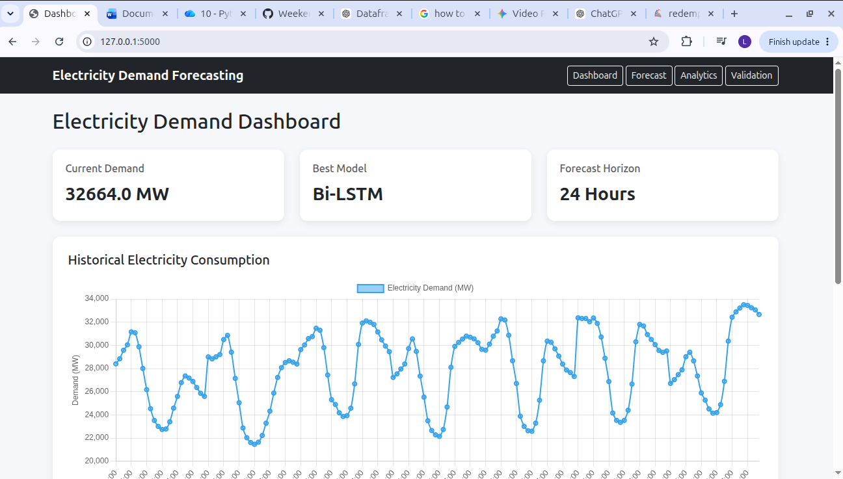 Dashboard Page

CHAPTER 26. FORECAST ROUTE
The main forecasting route is:
@app.route(
"/forecast",
methods=["GET", "POST"]
)
def forecast_page():

Why this route is used
The page must support:
GET → Display forecasting page
POST → Generate forecast

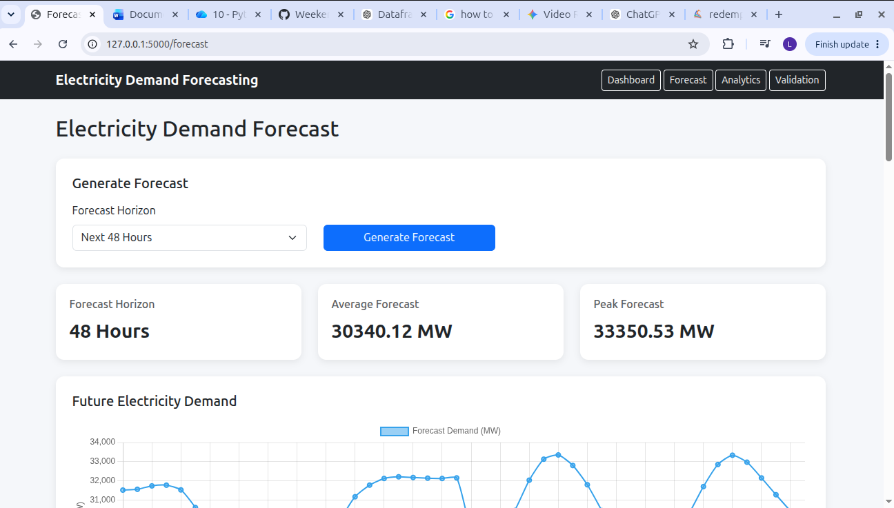 forecast Page

CHAPTER 27. LOADING THE PROCESSED DATA
df = pd.read_csv(
"../Dataset/final_df.csv"
)
df["Datetime"] = pd.to_datetime(
df["Datetime"]
)
df = df.sort_values(
"Datetime"
).reset_index(drop=True)

Why this code is used
The Flask application must use the same processed features used during model training.
The data is sorted chronologically to make sure the latest observations are correctly identified.

CHAPTER 28. SELECTING THE LATEST SEQUENCE
latest_features = df[
features
].tail(48)

Why this code is used
The selected model was trained using a 48-hour historical sequence.
Therefore, the application takes the latest 48 observations as input.
The resulting data contains:
48 time steps
×
19 features

CHAPTER 29. LOADING THE SCALERS
X_scaler = joblib.load(
"../Models/X_scaler.pkl"
)
y_scaler = joblib.load(
"../Models/y_scaler.pkl"
)

Why this code is used
The same scalers used during training must be used during prediction.
Otherwise, the input distribution seen by the model would be different from the training distribution.

CHAPTER 30. SCALING THE INPUT
latest_scaled = X_scaler.transform(
latest_features
)

Why this code is used
The latest input must be transformed using the training scaler before being passed to the neural network.

CHAPTER 31. RESHAPING THE INPUT
X_input = latest_scaled.reshape(
1,
48,
19
)
The model expects:
Samples × Time Steps × Features
Therefore:
1 × 48 × 19
means:
1 sample
48 historical hours
19 features

CHAPTER 32. GENERATING THE FORECAST
prediction_scaled = model.predict(
X_input,
verbose=0
)

Why this code is used
The trained Bi-LSTM receives the latest historical sequence and generates the predicted future demand.

CHAPTER 33. CONVERTING PREDICTIONS BACK TO MW
prediction = (
y_scaler
.inverse_transform(
prediction_scaled.reshape(-1, 1)
)
.flatten()
)

Why this code is used
The model predicts values in the scaled target space.
Users need predictions in the original unit:
MW
Therefore, inverse_transform() converts the predictions back to their original scale.

CHAPTER 34. GENERATING FUTURE TIMESTAMPS
forecast_dates = pd.date_range(
start=last_timestamp
+ pd.Timedelta(hours=1),
periods=len(forecast),
freq="h"
)

Why this code is used
The predictions represent future hourly demand.
Therefore, the application generates corresponding future timestamps.
For example:
Last historical observation
↓
+1 hour
+2 hours
+3 hours
…

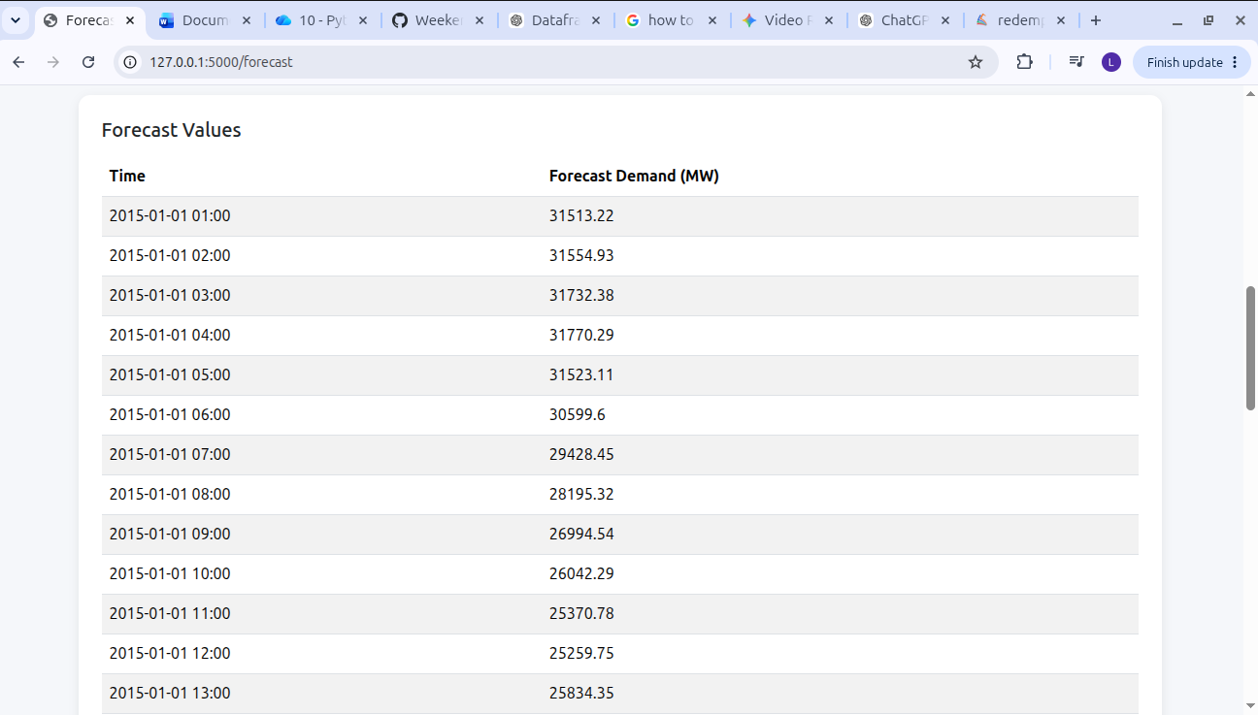 Future Forecast

CHAPTER 35. FORECAST SUMMARY
The application calculates:
average_forecast = round(
float(np.mean(forecast)),
2
)
and:
peak_forecast = round(
float(np.max(forecast)),
2
)

Why these are used
The user can quickly understand the forecast without examining every individual value.
The dashboard displays:
Forecast Horizon
Average Forecast
Peak Forecast

CHAPTER 36. FORECAST PAGE
The Forecast page provides:
- Forecast horizon selection
- Generate Forecast button
- Forecast summary
- Forecast chart
- Forecast table
The user can select:
24 Hours
48 Hours
72 Hours
and generate the corresponding forecast.

CHAPTER 37. ANALYTICS PAGE
The Analytics page provides:
Latest Demand
Maximum Demand
Minimum Demand
Historical Demand
Model Comparison
Forecast Error
Peak Demand Analysis
Forecast Performance
This page is designed to help users understand model behavior rather than simply view future predictions.
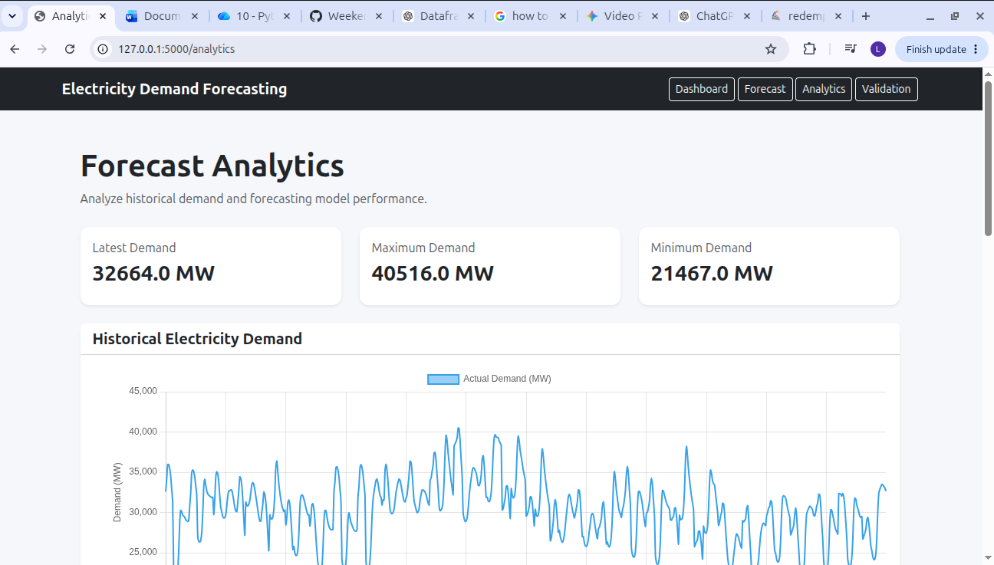 Analytics Page

CHAPTER 38. VALIDATION PAGE
The validation page provides a dedicated interface for:
30-Day Validation
60-Day Validation
The user can compare:
Actual Demand
vs
Predicted Demand
and view:
MAE
RMSE
MAPE
R²
along with graphical performance analysis.

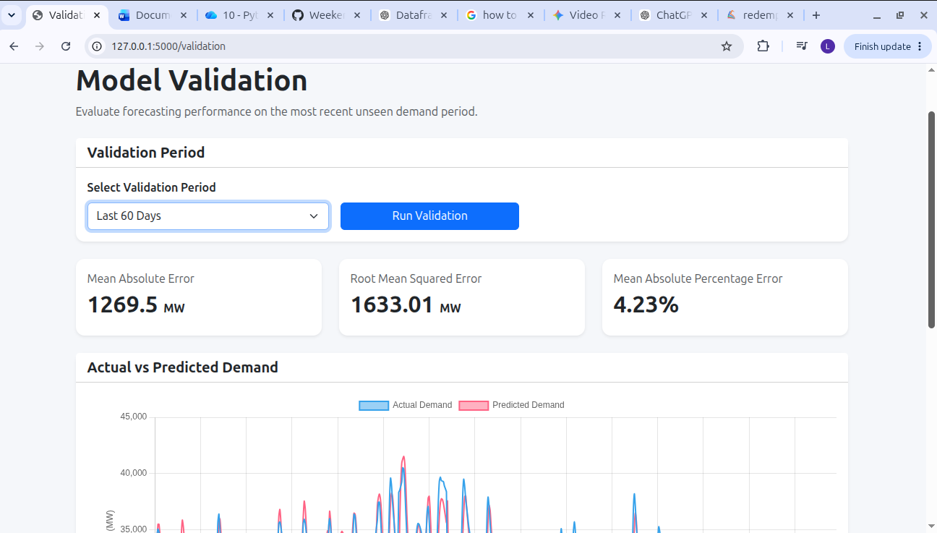 Validation Page

CHAPTER 39. SYSTEM ARCHITECTURE
The complete system can be represented as:
┌─────────────────────┐
│ PJM Energy Dataset │
└──────────┬──────────┘
│
↓
┌─────────────────────┐
│ Data Preprocessing │
└──────────┬──────────┘
│
↓
┌─────────────────────┐
│ Feature Engineering │
│ Lag + Rolling + Time │
└──────────┬──────────┘
│
↓
┌─────────────────────┐
│ Feature Scaling │
└──────────┬──────────┘
│
↓
┌─────────────────────┐
│ Sequence Creation │
└──────────┬──────────┘
│
↓
┌──────────────────────────┐
│ RNN / LSTM / GRU / │
│ Bidirectional LSTM │
└────────────┬─────────────┘
│
↓
┌─────────────────────┐
│ Model Evaluation │
└──────────┬──────────┘
│
↓
┌─────────────────────┐
│ Best Model │
│ 168-Hour Bi-LSTM │
└──────────┬──────────┘
│
↓
┌─────────────────────┐
│ Flask Application │
└──────────┬──────────┘
│
┌─────────────┼──────────────┐
↓ ↓ ↓
Forecast Analytics Validation

CHAPTER 40. RESULTS AND DISCUSSION
The experiments demonstrate that recurrent deep learning models can learn meaningful temporal patterns from historical electricity demand.
Among the tested architectures, the Bidirectional LSTM produced strong results, particularly with the 168-hour input sequence.
The 168-hour Bi-LSTM achieved:
Metric | Result
MAE | 1716.29 MW
RMSE | 2290.09 MW
MAPE | 5.67%
R² | 0.8747
Bias | 216.42  MW
The experiment with different sequence lengths also demonstrates that increasing the historical window does not automatically improve forecasting performance. The 168-hour sequence performed better overall than the tested 24-hour and 48-hour configurations for the selected Bi-LSTM model.

CHAPTER 41. CONCLUSION
The project successfully developed an end-to-end electricity demand forecasting system using deep learning.
The project began with raw historical electricity demand data and progressed through preprocessing, temporal feature engineering, lag generation, rolling statistics, exploratory analysis, baseline forecasting, sequence creation, deep learning model development, hyperparameter tuning, and model evaluation.
Four recurrent architectures were compared:
RNN
LSTM
GRU
Bi-LSTM
Different historical sequence lengths were also evaluated. Based on the reported experiments, the 48-hour Bi-LSTM was selected as the main forecasting model.
Finally, the model was integrated into a Flask web application containing:
Dashboard
Forecast
Analytics
Validation
The resulting system provides both future electricity demand predictions and visual analytical tools for evaluating forecasting performance.

